Please pray for:
Church Family: Charlie Asbury and family (Charlie’s recovery and Peggy’s death); Phil Kennedy (cancer); Connie Fletcher; Doris Branham; Charlie and Pam Irvin (death of Pam’s cousin, Douglas Creasy). Heritage Hall: Robert Heldreth III; Dorothy Nuckles, Betty Kelly, Richard Witten, Daisy Larimer. Dogwood Crossing: Marlene Buffalow; Dorothy Gess Jonas; Sunnyside: Anne Bishop; Homebound: Madeline Hurt, Louise Smith, Renia Hale Peery

Others: Will Calfee (cancer complications); Herbie Yost (mother’s death); Cole Ramey; Theresa Huffman; Donna McCann (cancer); Bob Woodbury; Jollie Pennell.
Active Military Personnel: Jon Wright

Missionaries: Michael & Rachel Weller (presently in U.S.).
To pass along a prayer request, contact Eunice Lester (276.988.4412) jnseun@aol.com); or the church office (276.988.4724; sectazpresb12@yahoo.com).

Names will remain on the Prayer List for 4 weeks, unless otherwise requested.
_____________________________________________________________________
Attendance Last Sunday: Services cancelled due to COVID-19

Lectionary Scripture Readings for the Day
1 Samuel 16:1-13 Psalm 23
Ephesians 5:8-14 John 9:1-41

ANNOUNCEMENTS

- All worship services and church gatherings on hold for the time being.

- Session Meeting this coming Friday

- “Daily Grace”

- “Hymn of the Day”

- Worship Service on You Tube

- “Your Experience in the Crisis”

- Email updates/ Information Sheets

- Weekly “Lamplighter”

- Continuing Financial Support

- Food Pantry
The Food Pantry requests for March are “Canned Fruit and Soap.”

Tazewell Presbyterian Church
& Black’s Presbyterian Chapel
Church Office: 149 Church Street, PO Box 26 Tazewell, VA
On the web at www.tazpreschurch.org
phone: 276-988-4724 preschool 276-988-5108
email address: sectazpresb12@yahoo.com


Tazewell Presbyterian Church
& Black’s Chapel

March 22, 2020
Fourth Sunday in Lent
___________________________________________________________________________

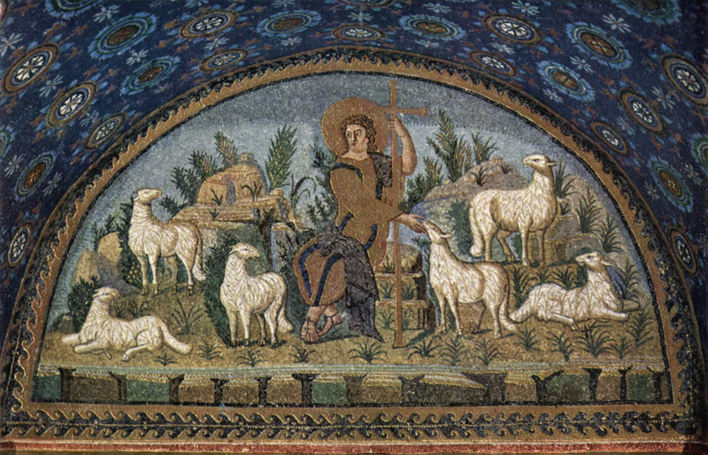

“Christ the Good Shepherd”
5th century, mosaic, Ravenna, Italy
______________________________________________________

WELCOME AND ANNOUNCEMENTS

*CALL TO WORSHIP (Psalm 23, KJV)
The Lord is my shepherd; I shall not want.
He maketh me to lie down in green pastures:
he leadeth me beside the still waters;
he restoreth my soul.
He leadeth me in the paths of righteousness
for his name’s sake.
Yea, though I walk through the valley of the shadow of death,
I will fear no evil:
for thou art with me;
thy rod and thy staff they comfort me.
Thou preparest a table before me
in the presence of mine enemies:
thou anointest my head with oil;
my cup runneth over.
Surely goodness and mercy shall follow me
all the days of my life:
and I shall dwell in the house of the Lord
forever.
PRAYER OF ADORATION AND THE LORD’S PRAYER (in unison)
Our Father, who art in heaven,
hallowed be thy name.
Thy kingdom come,
thy will be done, on earth as it is in heaven.
Give us this day our daily bread;
and forgive us our debts,
as we forgive our debtors;
and lead us not into temptation,
but deliver us from evil.
For thine is the kingdom, and the power,
and the glory, forever. Amen.

SILENT REFLECTION AND CONFESSION

ASSURANCE OF FORGIVENESS
This is the good news of God’s grace:
though we thirst for things that will never satisfy us;
though we commit ourselves to things that will never last;
though we worship things that will never bring us salvation,
still God loves us and never, EVER gives up on us.
But offers us the gift of living water,
to quench our deepest thirsts
unto eternal life.

Friends, believe the good news:
Christ has become our life and salvation.
In Him we are forgiven.
Thanks be to God!

*THE PEACE
The peace of Christ be with you.
And also with you.

SCRIPTURE READING
John 9:1-41
As he walked along, he saw a man blind from birth. His disciples asked him, “Rabbi, who sinned, this man or his parents, that he was born blind?” Jesus answered, “Neither this man nor his parents sinned; he was born blind so that God’s works might be revealed in him. We must work the works of him who sent me while it is day; night is coming when no one can work. As long as I am in the world, I am the light of the world.”
When he had said this, he spat on the ground and made mud with the saliva and spread the mud on the man’s eyes, saying to him, “Go, wash in the pool of Siloam” (which means Sent). Then he went and washed and came back able to see.
The neighbors and those who had seen him before as a beggar began to ask, “Is this not the man who used to sit and beg?” Some were saying, “It is he.” Others were saying, “No, but it is someone like him.” He kept saying, “I am the man.” But they kept asking him, “Then how were your eyes opened?” He answered, “The man called Jesus made mud, spread it on my eyes, and said to me, ‘Go to Siloam and wash.’ Then I went and washed and received my sight.” They said to him, “Where is he?” He said, “I do not know.”
They brought to the Pharisees the man who had formerly been blind. Now it was a sabbath day when Jesus made the mud and opened his eyes. Then the Pharisees also began to ask him how he had received his sight. He said to them, “He put mud on my eyes. Then I washed, and now I see.” Some of the Pharisees said, “This man is not from God, for he does not observe the sabbath.” But others said, “How can a man who is a sinner perform such signs?” And they were divided. So they said again to the blind man, “What do you say about him? It was your eyes he opened.” He said, “He is a prophet.”
The Jews did not believe that he had been blind and had received his sight until they called the parents of the man who had received his sight and asked them, “Is this your son, who you say was born blind? How then does he now see?” His parents answered, “We know that this is our son, and that he was born blind; but we do not know how it is that now he sees, nor do we know who opened his eyes. Ask him; he is of age. He will speak for himself.” His parents said this because they were afraid of the Jews; for the Jews had already agreed that anyone who confessed Jesus to be the Messiah would be put out of the synagogue. Therefore his parents said, “He is of age; ask him.”
So for the second time they called the man who had been blind, and they said to him, “Give glory to God! We know that this man is a sinner.” He answered, “I do not know whether he is a sinner. One thing I do know, that though I was blind, now I see.”
They said to him, “What did he do to you? How did he open your eyes?” He answered them, “I have told you already, and you would not listen. Why do you want to hear it again? Do you also want to become his disciples?” Then they reviled him, saying, “You are his disciple, but we are disciples of Moses. We know that God has spoken to Moses, but as for this man, we do not know where he comes from.”
The man answered, “Here is an astonishing thing! You do not know where he comes from, and yet he opened my eyes. We know that God does not listen to sinners, but he does listen to one who worships him and obeys his will. Never since the world began has it been heard that anyone opened the eyes of a person born blind. If this man were not from God, he could do nothing.”
They answered him, “You were born entirely in sins, and are you trying to teach us?” And they drove him out.
Jesus heard that they had driven him out, and when he found him, he said, “Do you believe in the Son of Man?” He answered, “And who is he, sir? Tell me, so that I may believe in him.” Jesus said to him, “You have seen him, and the one speaking with you is he.” He said, “Lord, I believe.” And he worshiped him.
Jesus said, “I came into this world for judgment so that those who do not see may see, and those who do see may become blind.”
Some of the Pharisees near him heard this and said to him, “Surely we are not blind, are we?” Jesus said to them, “If you were blind, you would not have sin. But now that you say, ‘We see,’ your sin remains.
The Word of the Lord.
Thanks be to God.

SERMON Dave Gilbert
“Heart Blindness”
OFFERING

*DOXOLOGY
Praise God, from whom all blessings flow;
Praise Him, all creatures here below;
Praise Him above, ye heavenly host;
Praise Father, Son, and Holy Ghost. Amen.

CONCERNS AND CELEBRATIONS

PRAYERS OF THANKSGIVING, INTERCESSION, AND PETITION
We lift our voices in prayers of praise, holy God, for you have lifted us to new life in Jesus Christ, and your blessings come in generous measure. Even in this time of uncertainty amidst the growing COVID-19 crisis we claim your blessings. Especially we thank you for
the privilege of worship and service in this congregation…..
the good news of the gospel which assures us that nothing in life or
in death can separate us from your love in Jesus Christ our Lord. . .
for food and drink we have to share in the Lord’s name. . . .
our calling to discipleship . . . .

We hold up before you human needs, God of compassion, for you have come to us in Jesus Christ and shared our life so we may share his resurrection. Especially we pray for
the healing of those who are sick. . . .
the comfort of the dying. . . .
the renewal of those who despair . . .
for health workers, --- doctors, nurses, lab techs, all engaged in the
mighty enterprise of saving lives . . .
and we pray for your Spirit’s power in the church . . . .

Great God, you are one God,
and you bring together what is scattered
and mend what is broken.
Though we are physically separated one from another
unite us in the bond of Christ’s love.
Bind up all our wounds,
and heal us in spirit,
that we may be renewed as disciples of Jesus Christ,
our Master and Savior and Friend.
Amen.

*BENEDICTION
May the Lord, who is our peace,
give us peace at all times and in every way,
and bring us to everlasting life. Amen.

