Welcome! Greetings in the name of Christ to all who are worshiping with us online today! Whether you are a longtime member or a guest, we are blessed to have you with us.

Please remember in prayer . . .
CHURCH FAMILY: Connie Fletcher (death of sister, Dot); Dorothy Wright (challenges after Roy’s death); Charlie Asbury; Phil Kennedy; Doris Branham; Heritage Hall: Robert Heldreth III; Dorothy Nuckles, Betty Kelly, Richard Witten. Dogwood Crossing: Marlene Buffalow; Dorothy Gess Jonas; Daisy Larimer Sunnyside: Anne Bishop; Homebound: Madeline Hurt, Louise Smith, Renia Hale Peery.

OTHERS:
Kim McGraw’s mother (transition challenges); Susan Royal Whittaker (broken hip from fall); Jennifer Brewster (cancer); Kim and David Calfee and the Calfee family upon the death Will Calfee (age 18). Mary Densen (death of father); Barbara French (rehab following stroke).

ACTIVE MILITARY PERSONNEL: Jon Wright

MISSIONARIES: Michael & Rachel Weller (presently in U.S.)
To pass along a prayer request, contact Eunice Lester at (276.988.4412) jnseun@aol.com); or by contacting the church office at (276.988.4724; sectazpresb12@yahoo.com). Names will remain on the Prayer List for 4 weeks, unless otherwise requested.

Calendar of Events
This Week
Tues June 30 11:00 am Table Talk Book Discussion
Wed July 1 1:00 pm Worship Committee
7:30 pm Wednesday Vespers (Zoom)
Sun July 5 9:00 am Worship: Black’s Chapel
11:00 am Worship: Tazewell Presbyterian

News and Notes

CHURCH REOPENING
Worship services at both Tazewell Presbyterian and Black’s Chapel will resume next Sunday. An explanation of our Reopening Protocol has been mailed and all are encouraged to read it. If you feel for health reasons that it is not yet time for you to gather with the church assembled we understand and look forward to the time when you will feel comfortable returning to church.

SERVICE PRE-RECORDINGS GOING TO “LIVE-STREAMING”
Pre-recordings of Sunday services will discontinue with today’s service. However, we will soon begin “live-streaming” our 11:00 service so that those who need to worship from home may join in simultaneously. “Live-stream” recordings of services will also be available through the church’s website.

WEDNESDAY VESPERS
Every Wednesday evening at 7:30 pm we share in a midweek vespers service over ZOOM. Each Wednesday morning an email invitation is sent out. Look for it.

MOTHER’S DAY/FATHER’S DAY OFFERING
You can still make an offering to the Mother’s Day/Father’s Day Offering which supports the Sunnyside Communities Fellowship Fund. The fund provides financial and personal resources for residents who can no longer fully pay their way. Sunnyside Communities was founded as a Presbyterian Ministry of the Historic Synod of the Virginias in 1912 and serves more than 800 older adults in three retirement communities: Sunnyside in Harrisonburg, Summit Square in Waynesboro and King’s Grant in Harrisonville.

TABLE TALK BOOK SELECTION
Our current book is “UNAFRAID: Living with COURAGE and HOPE in UNCERTAIN TIMES” by best-selling author and pastor, Adam Hamilton. We meet on Tuesdays at 11:00 am in Fellowship Hall (and via Zoom for those who wish join in virtually). Copies of the book are available from the church office.

FOOD PANTRY
The Food Pantry is currently open two days per week, on Tuesdays and Thursdays from 12:00 noon to 3 pm.

LECTIONARY SCRIPTURE READINGS FOR THE DAY
Genesis 22:1-14 Psalm 13
Romans 6:12-23 Matthew 10:40-42

TAZEWELL
PRESBYTERIAN CHURCH
& BLACK’S PRESBYTERIAN CHAPEL
A Member of the Abingdon Presbytery of the Presbyterian Church (USA)
149 Church Street, PO Box 26, Tazewell, VA
phone: 276-988-4724 preschool 276-988-5108
email address: sectazpresb12@yahoo.com
www.tazpreschurch.org

TAZEWELL PRESBYTERIAN CHURCH
& BLACK’S PRESBYTERIAN CHAPEL

June 28, 2020
Fourth Sunday after Pentecost
_______________________________________________________________


We regret that we cannot gather in person, but we are grateful to be gathered in spirit. We invite you to spend a few moments in quiet meditation to prepare yourself for worship and allow yourself to be surrounded by the peace of Christ before we begin.
The Order of Worship
PRELUDE

WELCOME AND LIFE OF THE CHURCH Dr. Dave Gilbert

PASSING OF THE PEACE

INTROIT “Great is Thy Faithfulness”

†CALL TO WORSHIP Barbara Kincer
Leader: We come to praise you, God.
People: For you are the living God who made the heavens, the earth,
the sea and everything in them.
Leader: You have shown us kindness by giving us rain from heaven
and seasons of harvest.
People: You provide us with food for our bodies and trials for the
strengthening of our souls.
All: We will rejoice and worship You!

†OPENING HYMN BEACH SPRING
“God, Whose Giving Knows No Ending”

God, whose giving knows no ending, from your rich and endless store,
nature’s wonder, Jesus’ wisdom, costly cross, grave’s shattered door:
gifted by you, we turn to you, offering up ourselves in praise;
thankful song shall rise forever, gracious donor of our days.

Skills and time are ours for pressing toward the goals of Christ, your Son:
all at peace in health and freedom, races joined, the church made one.
Now direct our daily labor, lest we strive for self alone.
Born with talents, make us servants fit to answer at your throne.

Treasure, too, you have entrusted, gain through powers your grace conferred:
ours to use for home and kindred, and to spread the gospel word.
Open wide our hands in sharing, as we heed Christ’s ageless call,
healing, teaching, and reclaiming, serving you by loving all.

PRAYER OF ADORATION
INVITATION TO CONFESSION (A pause for silent confession follows.)
PRAYER OF CONFESSION
Almighty God, we confess how hard it is to be your people. You have called us to be the church, to continue the mission of Jesus Christ to our lonely and confused world. Yet we acknowledge we are more apathetic than active, isolated than involved, callous than compassionate, obstinate than obedient, legalistic than loving. Gracious Lord, have mercy upon us and forgive our sins. Remove the obstacles to our being your representatives to a broken world. Awaken our hearts to the promised gift of your indwelling Spirit. This we pray in Jesus’ powerful name. Amen.

ASSURANCE OF PARDON

†GLORIA PATRI
Glory be to the Father, and to the Son, and to the Holy Ghost:
As it was in the beginning, is now, and ever shall be, world without end.
Amen, Amen.

CHILDREN’S MESSAGE Barbara Kincer

SCRIPTURE Genesis 22:1-14

Leader: The word of the Lord.
All: Thanks be to God.

SERMON “Faith’s Ultimate Test” Dave Gilbert

†THE APOSTLE’S CREED
I believe in God the Father Almighty,
Maker of heaven and earth,
And in Jesus Christ His only Son our Lord;
who was conceived by the Holy Ghost,
born of the Virgin Mary,
suffered under Pontius Pilate,
was crucified, dead, and buried;
He descended into hell;
the third day He rose again from the dead;
He ascended into heaven,
and sitteth on the right hand of God the Father Almighty;
from thence He shall come to judge the quick and the dead.
I believe in the Holy Ghost;
the holy catholic church;
the communion of saints;
the forgiveness of sins;
the resurrection of the body;
and the life everlasting. Amen.

INVITATION TO OFFERING

†DOXOLOGY
Praise God, from whom all blessings flow;
Praise Him, all creatures here below;
Praise Him above, ye heavenly host;
Praise Father, Son, and Holy Ghost. Amen.

CELEBRATIONS AND CONCERNS

PRAYERS OF THANKSGIVING, INTERCESSION, AND PETITION

THE LORD’S PRAYER
Our Father who art in heaven, hallowed be thy name. Thy kingdom come, thy will be done, on earth as it is in heaven. Give us this day our daily bread; and forgive us our debts, as we forgive our debtors; and lead us not into temptation, but deliver us from evil. For thine is the kingdom and the power and the glory, forever. Amen.

†HYMN OF COMMITMENT FOUNDATION
“How Firm a Foundation”

How firm a foundation, ye saints of the Lord,
Is laid for your faith in God’s excellent Word!
What more can be said than to you God hath said,
To you, who for refuge to Jesus have fled?

“Fear not, I am with thee, O be not dismayed,
For I am thy God and will still give thee aid;
I’ll strengthen thee, help thee, and cause thee to stand,
Upheld by My righteous, omnipotent hand.

“When through the deep waters I call thee to go,
The rivers of sorrow shall not overflow;
For I will be near thee, thy troubles to bless,
And sanctify to thee thy deepest distress.

“When through fiery trials thy pathway shall lie,
My grace, all-sufficient, shall be thy supply;
The flame shall not hurt thee; I only design
Thy dross to consume, and thy gold to refine.

“The soul that on Jesus hath leaned for repose,
I will not, I will not desert to its foes;
That soul, though all hell should endeavor to shake,
I’ll never, no never, no never forsake.”

†CHARGE AND BENEDICTION

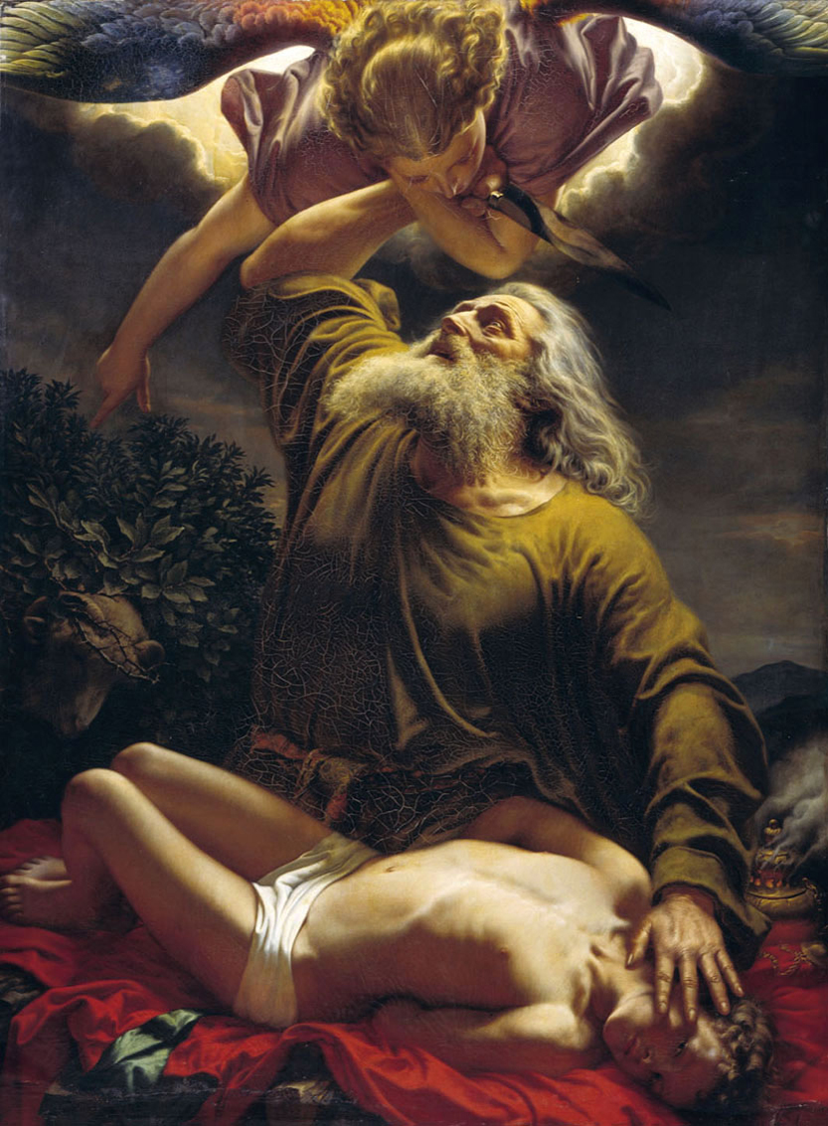
The Sacrifice of Isaac, Gerhardt Wilhelm von Reutern, 1794-1865

